Troop 313 Virtual Meeting Guidelines

Before participating in Virtual Troop or Patrol meetings, it is important that all leaders, Scouts and Parent(s)/Guardian(s) are familiar with the BSA’s Social Media Guidelines https://scoutingwire.org/social-media-guidelines/ and Scouting’s Youth Protection Guidelines and Barriers to Abuse, <https://www.scouting.org/training/youth-protection/>

It is important that all these safeguards are followed the same as they would be in an in-person setting.

Check out these great resources:

https://blog.scoutingmagazine.org/2015/04/06/no-one-one-contact-provision-applies-digital-contact/ from Bryan on Scouting on how Scouting’s Barriers to Abuse work online.

http://www.netsmartz.org/CellPhones

http://cdn.netsmartz.org/tipsheets/smartphone_safety.pdf

Virtual activities hosted by T313 are by choice and follow BSA Guidelines for participation and Rank Advancement. No exceptions can be made for Merit Badges or Rank Advancement that do not follow existing BSA guidelines. <https://www.scouting.org/coronavirus/covid-19-faq/>

Scoutmaster conferences must be requested by Scouts in advance via email, preferably through Scoutbook, and always include Parent/Guardian in responses. The Scoutmaster conference will then be scheduled for a later date, determined by Scoutmaster or Assistant Scoutmasters availability.

Uncheck the BCC box before sending your message so that each recipient of the email can see that the rules were followed. When this feature is unchecked, the reply all function is available.

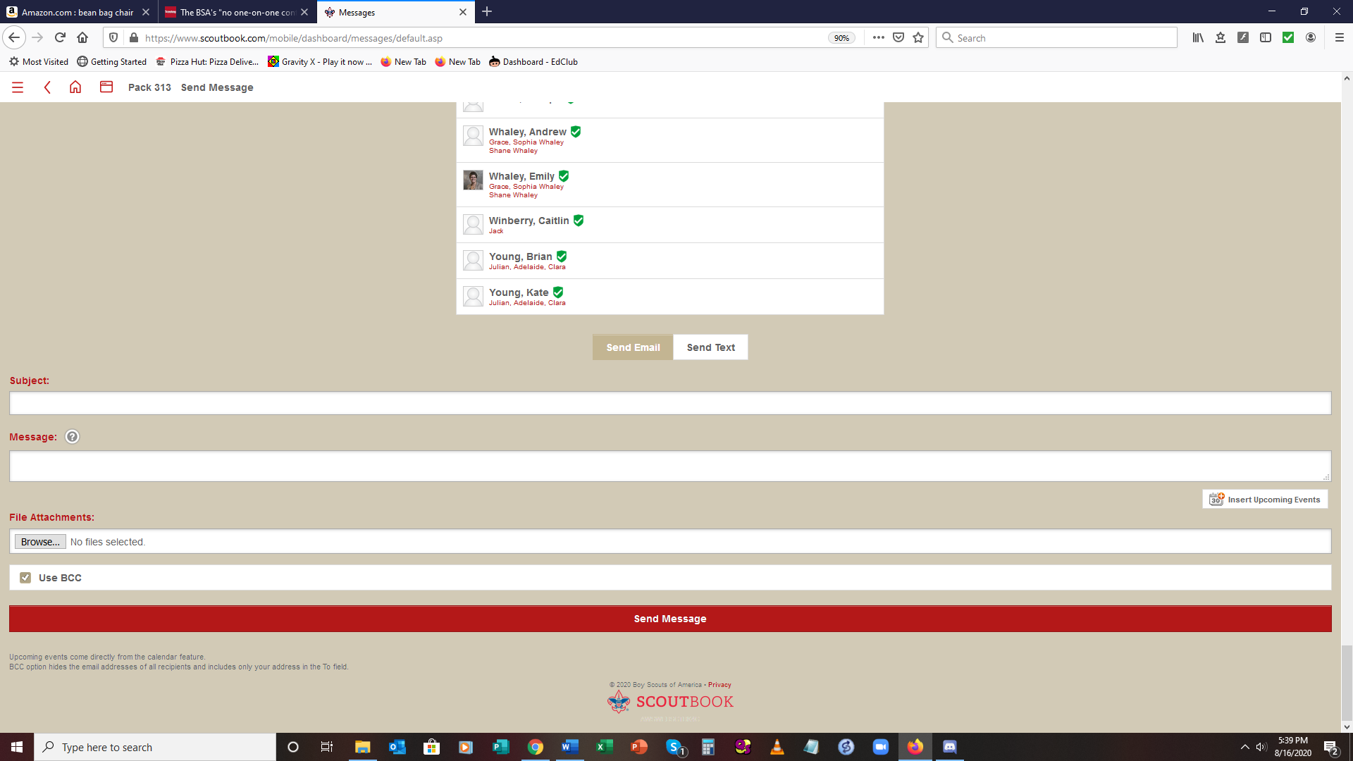

Board of Reviews must be requested by the Scout in advance before the start of the meeting via email, preferably through Scoutbook, and always include Parent/Guardian in responses. BOR’s will be scheduled at a later date, determined by availability of Committee Members. Remember to uncheck the BCC box before sending your message.

**Code of Conduct and Behavior Agreement**

The following is the Code of Conduct Scouts will need to adhere to in order to participate in this program. **Parent(s)/Guardian(s) and Scouts** must agree to follow the Code of Conduct and Behavior below in order to protect the health, safety and well- being of everyone at Troop 313 events.

Scouts must have completed BSA’s Cyber Chip Program to participate in Cyber Patrol meetings https://www.scouting.org/training/youth-protection/cyber-chip/ . There are four age-appropriate program levels and Scouts can earn a patch for completing. Cyber Chip training must be renewed every year.

**SECTION ONE: GENERAL PARTICIPATION**

**Consequences for the following**:

• **First Offense – Adult Leader will ask scout to stop**

• **Second Offense – Adult Leader will remind the Scout that this is the second offense and needs to stop**

• **Third Offense –** **Adult Leader will remove the Scout from the online session for the remainder of the meeting. Scoutmaster, Committee Chair, and Parent(s)/Guardian(s) and the Scoutmaster will be notified via email.**

1. Scouts will actively participate in all scheduled events to the best of their ability

2. Scouts should check their equipment 15 minutes prior to start of meeting

3. Scouts are expected to start meeting on time, with exception of prior notification with the Cyber Patrol Leader

4. Scouts are expected to use their first name, last initial to identify themselves

5. All Scouts will adhere to the dress code for each activity to ensure the safety and well-being of all participants. Scouts are expected to be appropriately dressed during video sessions to include Scout Uniform, unless otherwise designated by Cyber Patrol Leader.

a. Scouts will only use a blank background image or the Cyber Patrol background(s) that have been pre-approved by the Scoutmaster. They will be available on the Troop Webpage. Adult Leaders reserve the right to ask a Scout to remove an image if it is deemed inappropriate. No Scout will change, rotate, or reverse background during meeting, unless specifically directed by Adult Leader(s).

b. No overly distracting or inappropriate content/objects should be in the room within view of the camera.

c. No logos, slogans or graphics that contain language or images that would be inappropriate in a school setting (i.e., no alcohol, drugs, language or other content that would diminish the learning environment or create discomfort or harm for fellow participants.

6. It is essential that we protect the privacy and safety of our Scouts in a digital environment. Scouts shall not post information in any chat or online area that includes:

a. Full Name

b. Address

c. Phone Number

d. Email Address

7. Scouts must follow safety and security guidance of the Adult Leader(s) at all times. This includes all instructions given relating to appropriate use of the digital space, appropriate conduct within the space and appropriate use of all content and materials.

**SECTION TWO: DIGITAL ENGAGEMENT**

**Consequences for the following**:

• **First Offense – Adult Leader will ask scout to stop**

• **Second Offense – Adult Leader will remove the Scout from the online session for the remainder of the meeting. Scoutmaster, Committee Chair, and Parent(s)/Guardian(s) and the Scoutmaster will be notified via email.**

1. Scouts shall not take screen captures or use any other method to capture images of their fellow Scouts or any other individuals online in the program.

2. Scouts shall not use any of the available digital tools to promote, post, share or provide any material, language, images or content of an inappropriate, graphic, offensive, discriminatory, inflammatory or sexual nature.

3. Scouts shall not use any of the available digital tools to promote, post, share or provide any material, language, images, or content of a political or partisan nature.

4. Scouts shall not use any of the available digital tools to:

a. Disrupt the educational environment.

b. Violate federal or state law or regulation.

c. Violate Scouts BSA policy and procedures relating to Scout conduct and harassment. i.e.. Bullying, threats, etc.